Model System

The Model System provides an extra abstraction layer between the programming language used to develop an application and the storage used to persist data that is used by the application. It is concieved as a tool that should accelerate development and indirectly provide platform independence to the persisted data.

As a direct analogy one can think of the advantages of the Model Systems as those provided by a C compiler, meaning Portability (platform independence) and faster/easier development cycles with some added overhead as a disadvantage and after development is done the dependency on the Model System can be removed from the source through a process similar to compilation, which I call "optimization" (right now the terms aren't clearly defined). Much like the C compiler, once the system is ported to a new platform you will be able to use the data with the said platform, provided you've kept the Model Description Files (which are equivalent to the application source code from the C analogy).

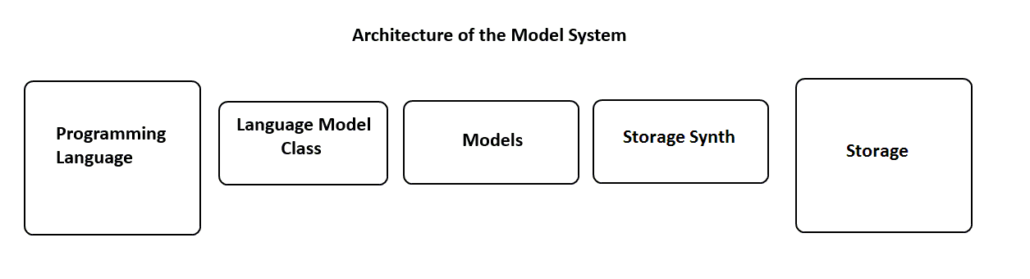
During the development cycle the system employs dynamic translation between the Programming Language and the Storage via the 3 components from above:

- Language Model Classes
- Models
- Storage Synth

Language Model Classes
These are the classes that allow the user to persist data in the storage. Any reference to these classes will be removed through optimization, being replaced directly by the optimized code.

- Model – this class contains an in memory representation of the Model Description Files. It is responsible for keeping a record of the type structure of the model and creating/retrieving instances of ModelObject objects. This class also keeps a registry of all the available models that the user can instance.
- ModelObject – represents an instance of a certain model.

Models
Represented by Model Description Files on your system storage, the Models represent the structure of a piece of data that you wish to work with in your application exp: Product, Manufacturer, Employee etc.

Storage Synth
The Storage Synth is used to translate the commands from the Language Model Classes into Storage commands. This part of the system is mostly used during the development phase and it is also used by the optimizer to generate optimized source code (which does not depend on the Model System) in order to boost performance and reliability in a production environment.
It should not be used in the production version of your application due to the extra overhead provided by the dynamic translation between model and storage commands, which should not normally be observed during development, but which might surface during heavy loads.

Model Description Files
These are the files that keep the structure of a particular information entity that you would like to work with in your application and would like to be kept on persistend storage. These files are kept in the "Mode Path" which is the list of directories where the system will search for the Model Description Files. A Model Description File looks something like:

Model Manufacturer:
short text Name
text Description
short text URL
short text ContactEmail
short data Picture

In the above example a Manufacturer model (which is ubiquitous information entity in a Retail application) is being described. The above model is being described in what I call the Intermediate Model Description Language.
The Intermediate Model Description Language is a lightweight set of rules for describing Models (information entities), which consists of the following simple rules:

1. The first line of a file using the IMDL has to be "Model ModelName:", where ModelName can be any unique name (a name that has not been used before by another model, i.e. there can never be more models with the same name).
2. The next lines may be blank or may contain a field.
3. References to other already existing Models may be used.

Next we will examine the last two rules, specifically what a field and what a reference is.

Fields
A field is a combination of a Basic Type and a Name. Fields are the basic storage unit of every Model and are capable of storing a single piece of data related to our Information Entity (for example a Manufacturer's Name is a field that holds textual data belonging to a Manufacturer. Each Manufacturer has its own name, which is not the same as the name of a Product – another type of Model that has a Name and is present in the retail domain).
In IMDL a single field is to be used per line due to concerns for readability and dynamic translation performance.

Ex:
short text Name
text Description

References
A reference is a special field that provides a means to include information about an already existing model in our current working model.
The perfect analogy (again from the retail field) would be a reference to a Manufacturer inside a Product field (should be read as, this product has a manufacturer).
At first the purpose of references might not be imediately clear (why not just include all the Manufacturer's fields inside the Product, or why even have a Manufacturer model at all – isn't keeping a simple manufacturer name field inside the Product model enough?).

References are what provide the relationships between our data.

The types of references that can be used in the IMDL are:
- singular references – a reference to a single Model instance
- multiple references – a reference to multiple instances of the same Model

Singular references are expressed by simply placing the Model name before the name of the reference, ex: Manufacturer ProductManufacturer

Multiple references use the "list of " identifier before the name of the Model to identify that the particular field references more instances of the Model, ex: list of Category ProductCategories

Basic Model Types
The IMDL contains a number of types that should allow a user to easily model any Information Entity that he has to work with in his application. These types were picked as a common base between the types used by the 2 most popular application development solution at this exact period in time (Jan 2014): PHP and MySQL. They are not absolute and may be subject to change and deprecation in the future.

short text - text that is at most 255 characters
text - any text, no limit here
short integer - a small number, no larger than 65,536
integer - 32 bit int, should suffice for most crap
long integer - 64 bit int, insane in the membrane type values
single float - small floating point number, i guess single precision as the IEEE likes to call it
double float - double precision float
short data - small binary value (eg: suitable for images/sound etc.)
data - arbitrary length binary data (eg: suitable for video)
bool - true/false, you already were expectin this
time - represents a time of the day
date - represents a date
time interval - difference in seconds between two date/times

The image below contains an overview of how the types of the PHP language are translated to MySQL types through the Model System.
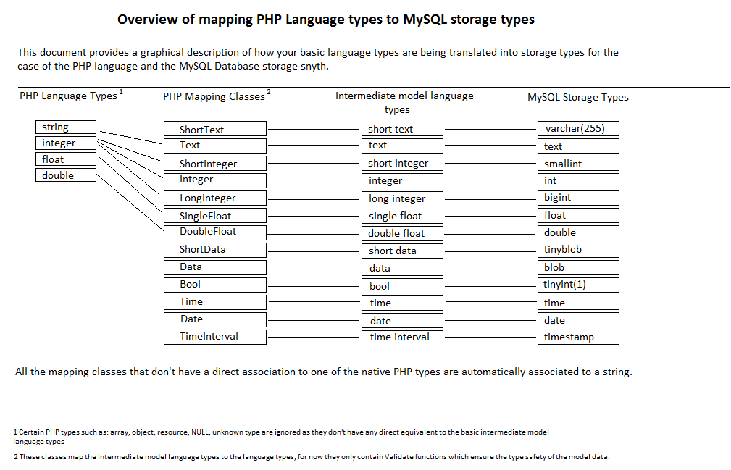
Type safety is an important consideration in the Model System, as inadequately treating the types of data might introduce unpredictable behaviour or data corruption.

In order to maintain type safety every Data Input Point must contain the necessary mechanisms to maintain type safety.

In the case of the Primary Implementation (PHP + MySQL) the only point where erronous data might be entered is the Programming Language (see the Model System Architecture), thus every piece of data that enters the Model System from the Programming Language side must be verified through the use of the Language Mapping Classes (these classes contain only the means to verify if a certain piece of data is of a particular type).

Example usage of the Model System from the PHP Language:

include "model.class.php";
include "mysql.synth.php";

Model::Initialize(".:./models:./storemodels", new MysqlSynthesizer("localhost", "root", "", "test"));

$product1 = Model::Type("Product")->Create(); // will return a model object of type Product
$product1 = Model::Type("Product")->Create(Field1Value, Field2Value, Field3Value);
$product2 = Model::Type("Product")->Retrieve("awesome stuff", "insane"); // willl return the model object which has name = "awesome stuff" and othername = "insane", if no such object exists you're going to get a big fat null

$manufacturer1 = Model::Type("Manufacturer")->Create('Jimmy Jackson', 'Electronics Engineer for the US Military', 'http://jj.usmil.gov', 'jj@usmil.gov');

$product1->set('Name', 'Incomprehensibly cool'); // This will set the name of the object to Incomprehensibly cool (basic type, no drama here)
$product1->set('otherName', 'awesomeness incarnate');
$product1->set("Manufacturer", $manufacturer1); // This has to realize that it isn't dealing with a basic type and to validate that the pointer/reference it has received is actually belonging to a ModelObject of type Manufacturer (this is where all the drama is)
$product1->get("Manufacturer"); // This just retrieves the value of the Manufacturer pointer, no drama here

$product1->set('Categories'); // ok, we're already getting into dramatic territory here
// Ok as categories is actually a list of type, it will be stored as an array/list so set wouldn't actually have much sense here (it's always going to be initialized with an array I presume. I guess i'm going to need to perform some tests to see how arrays are handled and if I can provide the user with a reference/pointer to the actual list of (actually I can't, I hate stoping myself in mid sentence but in PHP there's no support for arrays of a single type if i'm not mistaken).

From the above code example we can notice that in order to use the Model System we must first include the language classes and a synth class.
The system must be initialized with the path of the Model Description Files and a Storage Synthesizer before we can use any models.

When we need to access our models we will use the: Model::Type("ModelName") syntax, which gives us access to the functionality of our model.

When working with data records a ModelObject is used to encapsulate the actual data

Model Class Description

The model class will provide a

The next lines will provide a description of the programming interface for the Model class that is available to the user.

Static Methods:
- Initialize($modelPath, Synthesizer $currentSynth) – initializes the internal structures of the model class, must be run before any work with the model system can be done from the programming language.
- InitializeStorage() - instructs the storage synth to initialize its storage structures (if any)
- Type($modelName) – alias for the private LoadModel method intended to be used by the user when requesting services from a particular model
- GetModelName($firstLine) – used by the auxilliary model structures to parse the name of a model file (that's the sole reason that its public)

Methods:
- Create() - creates a new instance of a ModelObject with the model type of the model where the method is called. Data for the new MO can be specified as parameters in the type order defined in the model files.
- CreateList() - creates a new empty list for Mos of the model type where the method is called which can be used for "list of" references.
- Retrieve() - retrieves data from storage and encapsulates it in a ModelObject. Parameters for the record which is to be retrieved can be provided to the method in the order defined in the model file.
- GetFieldType($name) – returns the IMDL type of a field (intended to be used by MOs)
- IsInitialized() - returns the state of the storage initialization (intended to be used by Mos)

ModelObject Class Description

The ModelObject class encapsulates a particular row of data belonging to a Model to which the user can apply alterations, persist these alterations or delete the object alltogether.

Methods:
- Update() - persists any alterations performed to the model
- Delete() - deletes the model
- GetModel() - returns the model to which this MO belongs
- get($name) – returns the value of a Field
- set($name, value) – alters the value of a Field

